### 3.4.2 Use Cases

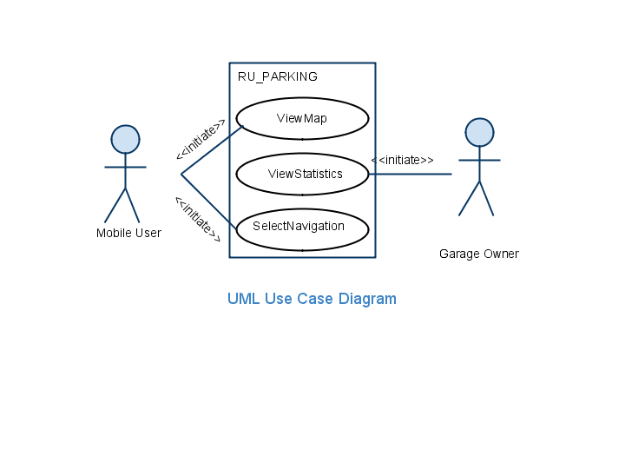

*Figure 3-5 High-level use cases for RU Parking*

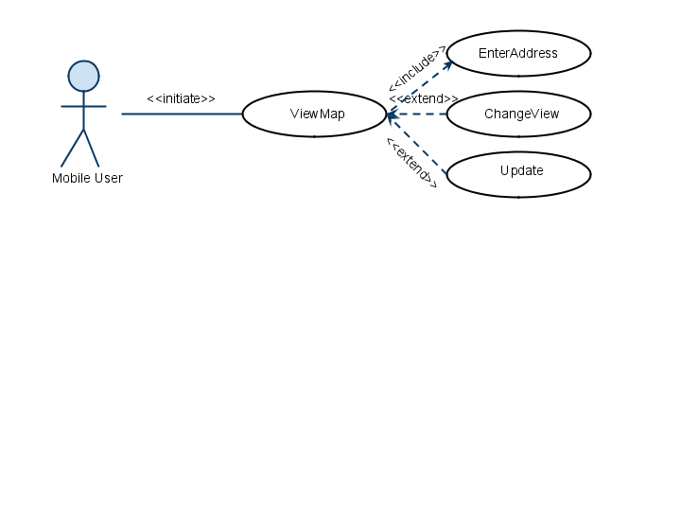

*Figure 3-6 Detailed use cases refining the ViewMap high-level use case.*

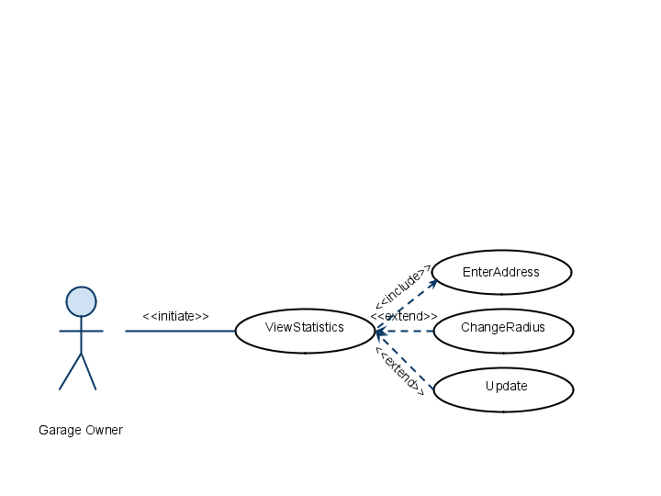

*Figure 3-7 Detailed use cases refining the ViewStatistics high-level use case.*

|  |  |
| --- | --- |
| Use case Name | ViewMap |
| Participating Actors | Initiated by MobileUser |
| Flow of Events | 1. MobileUser presses the “OpenApplication” button which creates an “InputAddress” form. 2. In this form the user can type in the destination address or select the current location as his input. Once the form is completed the MobileUser submits the form by pressing the “Submit” button, at which point the Server is notified. 3. The Server parses the information submitted by the MobileUser and submits parking availability data to the Application. 4. The Application uses this data to create a map which is then displayed on the LCD. |
| Entry Condition | MobileUser activates the “ViewMap” function of his phone. |
| Exit Condition | * The MobileUser presses the “ExitApplication” button. * The MobileUser presses the “ChangeView” button. * The MobileUser presses the “SelectStreet” button. * The MobileUser presses the “Update” button. |
| Quality Requirements | * Parking suggestion should be in real-time and accurate. * The colors in the map should be easily identifiable. |

*Figure 3-8 The ViewMap use case description.*

|  |  |
| --- | --- |
| Use case Name | ViewStats |
| Participating Actors | Initiated by GarageOwner |
| Flow of Events | 1. GarageOwner presses the “OpenApplication” button which creates an “InputAddress” form. 2. In this form the user can type in the destination address or select the current location as his input. Once the form is completed the GarageOwner submits the form by pressing the “Submit” button, at which point the Server is notified. 3. The Server parses the information submitted by the GarageOwner and submits parking availability data to the Application. 4. The Application uses this data to create a list which is then displayed on the LCD. |
| Entry Condition | GarageOwner activates the “ViewStats” function of his phone. |
| Exit Condition | * The GarageOwner presses the “ExitApplication” button. * The GarageOwner presses the “ChangeRadius” button. * The GarageOwner presses the “Update” button. |
| Quality Requirements | 1. Parking suggestion should be in real-time and accurate. |

*Figure 3-8 The ViewStatistics use case description.*

|  |  |
| --- | --- |
| Use case Name | SelectNavigation |
| Participating Actors | Initiated by Mobile User |
| Flow of Events | 1. The MobileUser presses the “SelectStreet” button. 2. Now the MobileUser is asked to confirm this by pressing a “Navigate” button. 3. A navigate request is sent to the Application. 4. The Application calls the “AddRouteToMap” function which generates the routing information. 5. This information is then sent to the LCD to be displayed. |
| Entry Condition | The MobileUser uses the “ViewMap” function. |
| Exit Condition | * The MobileUser presses the “ExitApplication” button. * The MobileUser pressing the “Cancel” button when asked for confirmation. |
| Quality Requirements | * The Application should suggest the best route on the basis of shorter distance or lesser time. * The directions should be timed correctly so that the user is informed on time. |

*Figure 3-9 The SelectNavigation use case description.*

|  |  |
| --- | --- |
| Use case Name | InputAddress |
| Participating Actors | Initiated by MobileUser or GarageOwner |
| Flow of Events | 1. MobileUser or GarageOwner presses the “OpenApplication” button which creates an “InputAddress” form. 2. In this form the user can type in the destination address or select the current location as his input. Once the form is completed the MobileUser or GarageOwner submits the form by pressing the “Submit” button, at which point the Server is notified. |
| Entry Condition | The MobileUser or the GarageOwner activates the Application. |
| Exit Condition | * The MobileUser or GarageOwner clicks on the “ExitApplication” button. * The MobileUser or GarageOwner clicks on the “Submit” button. |
| Quality Requirements | The form should be able to differentiate between street names, state names and ZIP codes. |

*Figure 3-10 The InputAddress use case description.*

|  |  |
| --- | --- |
| Use case Name | ChangeView |
| Participating Actors | Initiated by MobileUser |
| Flow of Events | 1. The MobileUser presses the”ChangeView” button while viewing the map on the LCD. 2. This sends a “ChangeView” request to the Application. 3. The Application then creates a new map having a different detail level. 4. This information is then sent to be displayed on the LCD. |
| Entry Condition | The MobileUser uses the “ViewMap” function. |
| Exit Condition | The Application displays the new map on the LCD. |
| Quality Requirements | The “ChangeView” function should have 3 distinct levels of detail to provide varying amounts of information to the user. |

*Figure 3-11 The ChangeView use case description.*

|  |  |
| --- | --- |
| Use case Name | ChangeRadius |
| Participating Actors | Initiated by GarageOwner |
| Flow of Events | 1. The GarageOwner presses the”ChangeRadius” button while viewing the list on the LCD. 2. This sends a “ChangeRadius” request to the Application. 3. The Application then creates a new list having a different amount of information. 4. This information is then sent to be displayed on the LCD. |
| Entry Condition | The GarageOwner uses the “ViewStats” function. |
| Exit Condition | The Application displays the new list on the LCD. |
| Quality Requirements | The “ChangeRadius” function should have 3 distinct details of information to provide to the user. |

*Figure 3-12 The ChangeRadius use case description.*

|  |  |
| --- | --- |
| Use case Name | Update |
| Participating Actors | Initiated by Mobile User and Garage Owner |
| Flow of Events | 1. The MobileUser or GarageOwner presses the “Update” button while viewing the map or list. 2. The request for update is sent to the Application. 3. The Application then submits the address to the Server. 4. The Server parses this information and sends relevant parking availability information to the Application. 5. The Application then creates a new map or list which is displayed on the LCD. |
| Entry Condition | The MobileUser uses the “ViewMap” function. |
| Exit Condition | The Application displays the new map or list on the LCD. |
| Quality Requirements | While updating the previous destination address of the user should be used. |

*Figure 3-13 The Update use case description.*